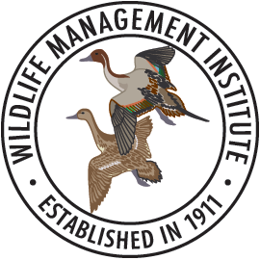

Developing Conservation Relationship Competencies
Name:
Organization:
Focus of current job responsibilities (50 words max):
Why is this training of interest to you? (150 words max):

